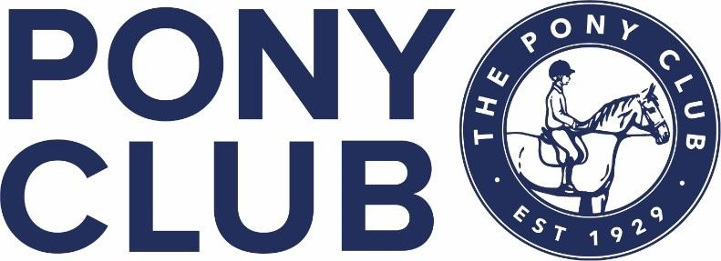

THE BISLEY & SANDOWN CHASE BRANCH OF THE PONY CLUB
AREA 13 PC80 & PC70 TEAM & INDIVIDUAL SHOW JUMPING &
PC70 DRESSAGE QUALIFIERS FOR
THE PONY CLUB NATIONAL REGIONAL CHAMPIONSHIPS 2022
Which are to be held at Rectory Farm, GL7 7JW on 27th-29th August 2022
https://www.rectoryfarm.com/area-9-show-jumping/grassroots-championships/

Sunday 26TH June 2022
At Dunstall Green Field,
Stonehill Road, Chobham GU24 8HP
With Kind Permission from Clemmie Shipp
PC80 Show Jumping Competition
PC70 Show Jumping Competition
PC70 Dressage Competition

Entries open: | Monday 23rd May 2022
Entries close: | Sunday 12th June 2022
Organisers: | Sue Seers
Course Builder: | Jenny Naylor
Online entries:
https://branches.pcuk.org/bisley/electronic-payments/
MEMBERS CAN ONLY ENTER WITH PERMISSION FROM DC/CENTRE PROPRIETOR/TEAM MANAGER
Entries Secretary: secretarybscpc@hotmail.com
Times and live scoring: www.ponyclubresults.co.uk
Farrier on call Refreshments (cash only)
On site Paramedics Vet on call
Photography by www.mhphotos.co.uk

PC70 REGIONAL QUALIFIER SHOW JUMPING COMPETITION  Open to Teams and Individuals  1st round - max height 70cm  2nd round – 70cm with 2 fences at 75cm  PLEASE NOTE  Riders are NOT eligible if they have previously completed at any PC80 (Grassroots) or above Area or Regional competition for Show Jumping.  As per Pony Club Show Jumping Rule book pages 36 & 37 | Entry Fee: £24
PC80 REGIONAL QUALIFIER SHOW JUMPING COMPETITION  Open to Teams and Individuals  1st round - max height 80cm  2nd round – 80cm with 2 fences at 85cm  PLEASE NOTE  Riders are NOT eligible if they have:  - Previously represented their Branch or Centre at PC90 level or above in any Show Jumping or Eventing summer Area Competitions or summer Championships.  Combination of Horse and Rider are NOT eligible if they have:  - Previously competed in the Spring Festival PC Challenge (90cm) Championship Final or Open competition at Area Level or above.  - Previously ever finished 1st to 3rd as an individual in the Show Jumping or Eventing at a Grassroots Regional Championships on two occasions  As per Pony Club Show Jumping Rule book pages 36 & 37 | Entry Fee: £24
PC70 DRESSAGE REGIONAL QUALIFIER  PC70 Eventing Dressage test 2022  PLEASE NOTE  This test may NOT be commanded and must be ridden in a snaffle bit (as described in the Pony Club Dressage rules 2022).  A whip may be carried | Entry Fee: £18.00

FOR BRANCH TEAMS, EITHER THE DC OR AN
APPOINTED BRANCH REPRESENTATIVE MUST EMAIL
THE SECRETARY WITH TEAM MEMBERS DETAILS
secretarybscpc@hotmail.com

Useful Information
- All classes will run on grass
- All Show Jumping classes will be over two jumping rounds and jump-off if deemed necessary.
- Teams will run in a drawn order which will be the same for the first two rounds.
- In the event of equality for qualifying places, there will be a timed jump off and the order of jumping will be drawn at that time. All Members of the team must jump off. The first member of each team in the jump-off will jump first followed by the second and so on.
- Numbers in the warm up will be limited. Please do not enter the warm up arena until you have been invited to by the steward

Rosettes
1st to 8th for individuals and 1st to 6th for teams

Entry Amendments
For any changes after the closing date please email Secretarybscpc@hotmail.com
Late entries will be charges an additional £5.00

AMENDMENTS AND SUBSITUTIONS CAN BE MADE ONLY WITH PERMISSION FROM DC/CENTRE PROPRIETOR/APPOINTED BRANCH REPRESENTATIVE

Withdrawals and refunds
Full refunds will be given up until the closing date of entries.

After the closing date no refunds will be made without a doctor’s or vet’s certificate produced no later than 24 hours after the event. If produced after this no refund will be given. Refunds where due after the closing date are subject to an admin fee of £5.

In the event of abandonment 50% of the entry fee will be refunded.

RULES AND CONDITIONS OF ENTRY
- The competition will be run in accordance with the Pony Club Show Jumping Rules 2022.
- There will be an unmounted prize giving after each class. Prize winning competitors are expected to be properly dressed as for competition for the prize giving.
- All hats to be worn in the competition must be checked as being tagged. Hats must conform to the current Pony Club standards and must have a chinstrap fastened at all times when mounted. In the interests of safety, the organisers reserve the right to eliminate anyone in breach of this rule.
- Protest and Objections: Please see the Pony Club Show Jumping Rule Book 2022.
- All dogs should be kept on a short lead at all time. Please clear up after your dog.
- Horses/ponies competing may only be ridden by their competitor, no other person is allowed to warm up / ride-in.
- Please clear up all hay and droppings from around your trailer/horse box. Please do not tie hay nets to the side of trailers/horse boxes.
- Stallions may only compete with a written letter of permission from your DC and should wear a disc. All horses and ponies must be aged 5 years or over, as defined in the Pony Club Show Jumping Rule Book 2022.
- All horses and ponies must be vaccinated as per Pony Club rules and random checks will be undertaken, so please ensure passports are available
- All horses and ponies, when outside the arena, should be moved at walk only to ensure the safety of all spectators and pedestrians
- For safety reasons, no jewellery (including sleepers) may be worn.
- No Lungeing is permitted anywhere on the showground

DISCLAIMER:
Save for the death or personal injury caused by the negligence of the organisers, or anyone for whom they are in law responsible, neither the organisers of this event or The Pony Club nor any agent, employee or representative of these bodies, nor the landlord or his tenant, accepts any liability for any accident, loss, damage, injury or illness to horses, owners, competitors, spectators or any person or property whatsoever, whether caused by their negligence, breach of contract or in any other way whatsoever. Entries are only accepted on this basis. The organisers of this event have taken all reasonable precautions to ensure the health & safety of everyone present at this event. For these measures to be effective everyone must take reasonable precautions to avoid and prevent accidents.
They must obey the instructions of the organisers and all officials and stewards.
PHOTOGRAPHIC RIGHTS:
Competitors and their guardians give permission for any photographic and/or film or TV footage taken of persons taking part in Pony Club events to be used and published in any media whatsoever for editorial purposes, press information or advertising by or on behalf of The Pony Club and/or official sponsors of The Pony Club.

